**Assignment:-1**

**STUDY OF UNIX OPERATING SYSTEM AND ITS FUNDAMENTALS**

**1.Operating system Defination**

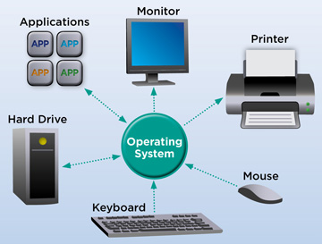

An operating system (OS) is the program that, after being initially loaded into the computer by a boot program,

manages all of the other application programs in a computer. The application programs make use of the operating system by making requests for services through a defined application program interface ([API](https://www.techtarget.com/searchapparchitecture/definition/application-program-interface-API)). In addition, users can interact directly with the operating system through a user interface, such as a command-line interface (CLI) or a graphical UI (GUI).

**2.List of operating system with there utility**

There are mainly 5 types:

a.Apple macOS,

b.Microsoft Windows,

c. Google's Android OS,

d. Linux Operating System,

e.Apple iOS.

Utilities available in a common operating system are

1. Process management

2. Memory management

3. File system

4. Device drivers

5. Networking

6. Security

7. Input/output operations

**Linux Operating System Utilities**

You can use the following Linux operating system utilities to monitor Vector:

•ps

•iostate

•vmstat

**Windows Operating System Utilities**

You can use the following Windows operating system utilities to monitor Vector:

•Windows Diagnostics

•Windows Performance Monitor

•Windows Event Viewer

•Windows Registry Editor

•Windows Task Manager

**MS-DOS Operating System**

A disk operating system (DOS) is an operating system for x86 based personal computers mostly developed by Microsoft. MS-DOS, its rebranding as IBM PC DOS, and some operating systems attempting to be compatible with MS-DOS. Sometimes it is referred to as "DOS", which is also the generic acronym for disk operating system.

#### Apple macOS.

Head-to-head in the competition with Microsoft Windows is Apple’s macOS. macOS and Windows are both examples of proprietary operating systems, meaning that the company conceptualized, designed, developed, and now sells their own OS. They’re designed and sold by the companies and aren’t meant to be tampered with or tweaked by users. Apple and Macintosh computers run on the proprietary macOS and OS X system, the first of which launched 20 years ago.

# 3.UNIX operating system

UNIX is a powerful Operating System initially developed by Ken Thompson, Dennis Ritchie at AT&T Bell laboratories in 1970. It is prevalent among scientific, engineering, and academic institutions due to its most appreciative features like multitasking, flexibility, and many more. In UNIX, the file system is a hierarchical structure of files and directories where users can store and retrieve information using the files.

## Features of UNIX Operating System:

Let's discuss the features of UNIX OS one by one in detail.

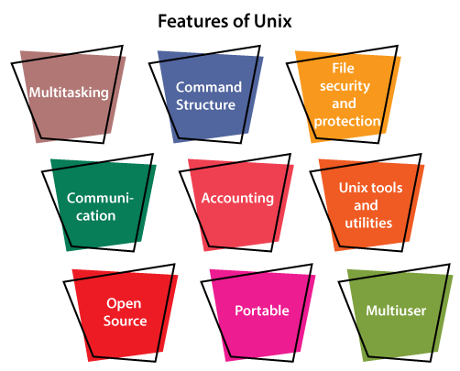

**Multitasking:** A UNIX operating system is a multitasking operating system that allows you to initiate more than one task from the same terminal so that one task is performed as a foreground and the other task as a background process.

**Multi-user:** UNIX operating system supports more than one user to access computer resources like main memory, hard disk, tape drives, etc. Multiple users can log on to the system from different terminals and run different jobs that share the resources of a command terminal. It deals with the principle of time-sharing.

**Portability:** This feature makes the UNIX work on different machines and platforms with the easy transfer of code to any computer system. Since a significant portion of UNIX is written in C language, and only a tiny portion is coded in assembly language for specific hardware.

**File Security and Protection:** Being a multi-user system, UNIX makes special consideration for file and system security. UNIX has different levels of security using assigning username and password to individual users ensuring the authentication, at the level providing file access permission viz. read, write and execute and lastly file encryption to change the file into an unreadable format.

**Command Structure:** UNIX commands are easy to understand and simple to use. Example: "cp", mv etc. While working in the UNIX environment, the UNIX commands are case-sensitive and are entered in lower case.

**Communication:** In UNIX, communication is an excellent feature that enables the user to communicate worldwide. It supports various communication facilities provided using the write command, mail command, talk command, etc.

**Open Source:** UNIX operating system is open source it means it is freely available to all and is a community-based development project.

**Accounting:** UNIX keeps an account of jobs created by the user. This feature enhances the system performance in terms of CPU monitoring and disk space checking. It allows you to keep an account of disk space used by each user, and the disk space can be limited by each other. You can assign every user a different disk quota. The root user can perform these accounting tasks using various commands such as quota, df, du, etc.

**HISTORY**

The Unix operating system found its beginnings in MULTICS, which stands for Multiplexed Operating and Computing System. The MULTICS project began in the mid 1960s as a joint effort by General Electric, Massachusetts Institute for Technology and Bell Laboratories. In 1969 Bell Laboratories pulled out of the project.

One of Bell Laboratories people involved in the project was Ken Thompson. He liked the potential MULTICS had, but felt it was too complex and that the same thing could be done in simpler way. In 1969 he wrote the first version of Unix, called UNICS. UNICS stood for Uniplexed Operating and Computing System. Although the operating system has changed, the name stuck and was eventually shortened to Unix.

Ken Thompson teamed up with Dennis Ritchie, who wrote the first C compiler. In 1973 they rewrote the Unix kernel in C. The following year a version of Unix known as the Fifth Edition was first licensed to universities. The Seventh Edition, released in 1978, served as a dividing point for two divergent lines of Unix development. These two branches are known as SVR4 (System V) and BSD.

Ken Thompson spent a year's sabbatical with the University of California at Berkeley. While there he and two graduate students, Bill Joy and Chuck Haley, wrote the first Berkely version of Unix, which was distributed to students. This resulted in the source code being worked on and developed by many different people. The Berkeley version of Unix is known as BSD, Berkeley Software Distribution. From BSD came the vi editor, C shell, virtual memory, Sendmail, and support for TCP/IP.

For several years SVR4 was the more conservative, commercial, and well supported. Today SVR4 and BSD look very much alike. Probably the biggest cosmetic difference between them is the way the *ps* command functions.

The Linux operating system was developed as a Unix look alike and has a user command interface that resembles SVR4.

**Distributions**

 Popular distributions include [Red Hat Enterprise Linux](https://en.wikipedia.org/wiki/Red_Hat_Enterprise_Linux), [Fedora](https://en.wikipedia.org/wiki/Fedora_Linux), [SUSE Linux Enterprise](https://en.wikipedia.org/wiki/SUSE_Linux), [openSUSE](https://en.wikipedia.org/wiki/OpenSUSE), [Debian](https://en.wikipedia.org/wiki/Debian), [Ubuntu](https://en.wikipedia.org/wiki/Ubuntu), [Linux Mint](https://en.wikipedia.org/wiki/Linux_Mint), [OpenMandriva](https://en.wikipedia.org/wiki/OpenMandriva_Lx), [Slackware Linux](https://en.wikipedia.org/wiki/Slackware), [Arch Linux](https://en.wikipedia.org/wiki/Arch_Linux) and [Gentoo](https://en.wikipedia.org/wiki/Gentoo_Linux).[[27]](https://en.wikipedia.org/wiki/Unix#cite_note-27)

## Applications

The applications and utility layer in Unix includes the word processors, graphics programs, database management programs, commands etc. The application programs provide an application to the end users.

For example, a web browser is used to find information while gaming software is used to play games. The requests for service and application communication systems used in an application by a programmer is known as an application program interface (API).

**4.COMPARISON OF WINDOWS AND UNIX**

|  |  |  |
| --- | --- | --- |
| **Features** | **UNIX Operating System** | **Windows Operating System** |
| **User-Interface** | It comes with a Command Line Interface (CLI). | It comes with a Graphical User Interface (GUI). |
| **Licensing** | It is a free and open-source operating system. | It is a licensed operating system. |
| **Security** | It is more secure because all system updates require explicit user permission. | It is less secure than UNIX operating system. |
| **Processing** | It supports multiprocessing. | It doesn't support multiprocessing. |
| **Case-Sensitive** | It is fully case-sensitive, and files can be considered separate files. | It has case sensitivity as an option. |
| **Basic** | It is a command-based operating system. | It is a menu-based operating system. |
| **Hardware** | In a UNIX system, hardware support is limited. Some hardware could not have drivers built-in. | Almost all hardware has drivers available. |
| **File System** | It uses the Unix File System (UFS), which includes the STD.ERR and STD.IO file systems. | It makes use of the New Technology File System (NTFS) and the File Allocation System (FAT32). |
| **Reliability** | Unix and its distributions are well known for their high level of stability. | Although Windows has become more stable in recent years, it still falls short of the reliability offered by Unix systems. |
| **Data Backup and Recovery** | Creating a backup and recovery system in UNIX is time-consuming, but it is becoming easier with the release of new Unix distributions. | It contains a built-in backup and recovery system that makes it more use |